**Exercise 2: E-commerce Platform Search Function**

**Scenario:**

You are working on the search functionality of an e-commerce platform. The search needs to be optimized for fast performance.

**Code:**

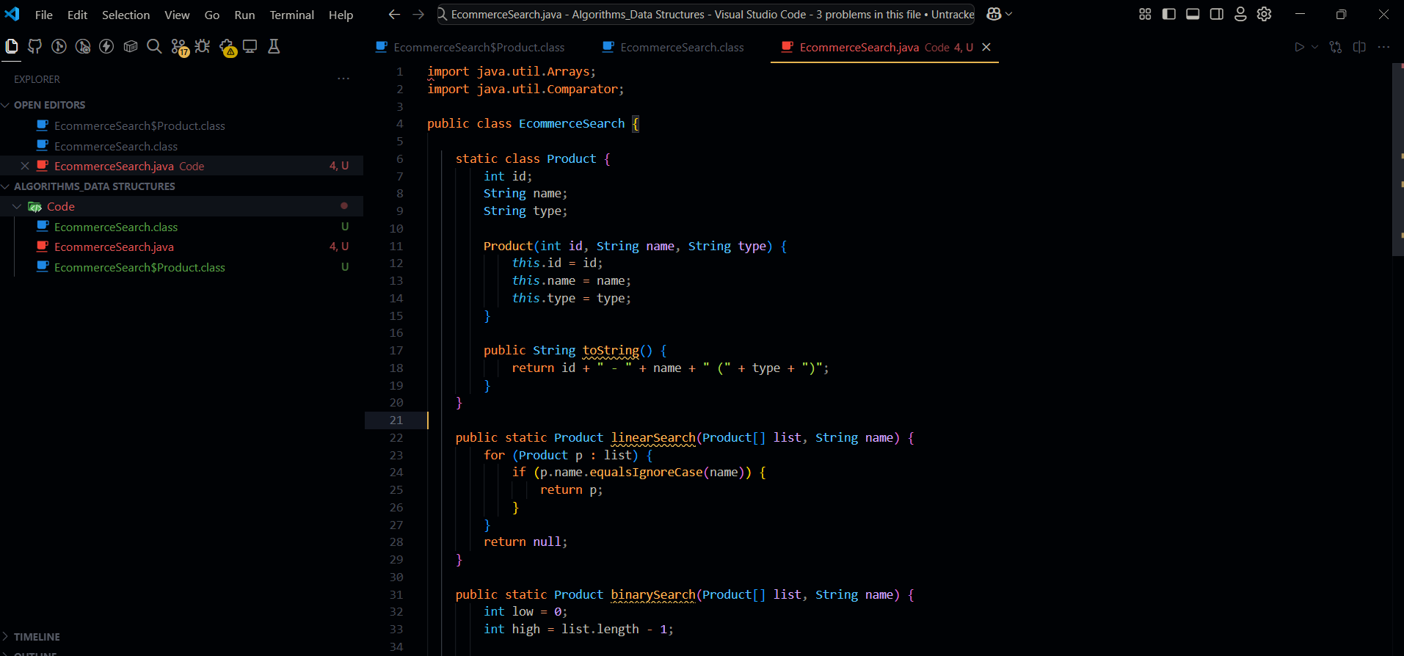

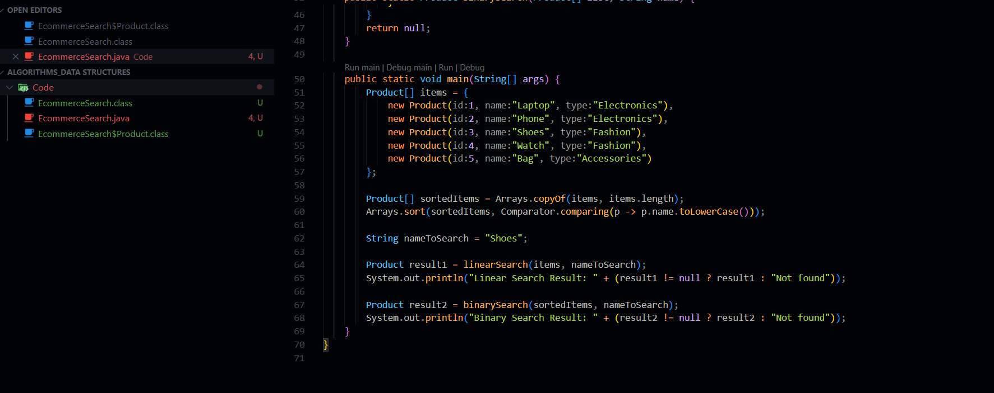

**;**

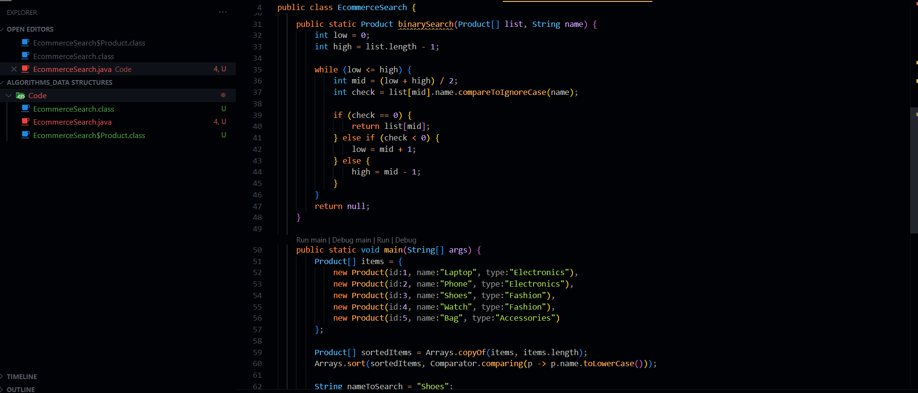

**Output:**

